**MongoDB -Aggregation Exercises**

Import the zips.json file into your MongoDB. Database name is "population" and collection name is "zipcodes".

**Atlanta Population**

1. use db.zipcodes.find() to filter results to only the results where city is ATLANTA and state is GA.

2. use db.zipcodes.aggregate with $match to do the same as above.

3. use $group to count the number of zip codes in Atlanta.

4. use $group to find the total population in Atlanta.

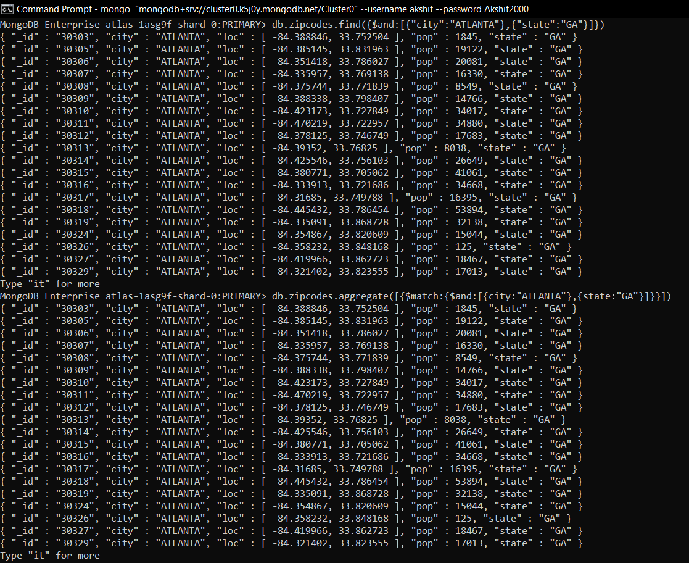

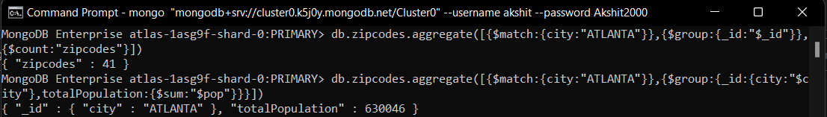

**Populations By State**

1. use aggregate to calculate the total population for each state

2. sort the results by population, highest first

3. limit the results to just the first 3 results. What are the top 3 states in population?

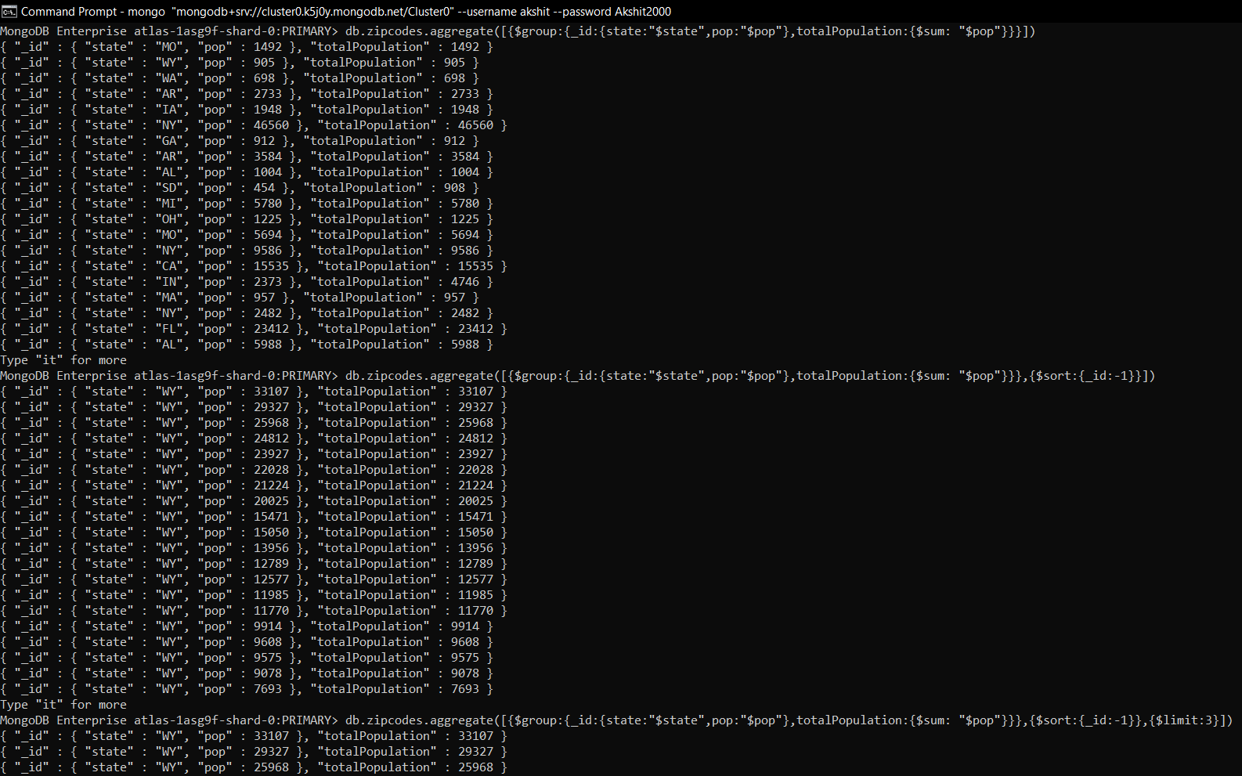

**Populations by City**

1. use aggregate to calculate the total population for each city (you have to use city/state combination). You can use a combination for the _id of the $group: { city: '$city', state: '$state' }

2. sort the results by population, highest first

3. limit the results to just the first 3 results. What are the top 3 cities in population?

4. What are the top 3 cities in population in Texas?

